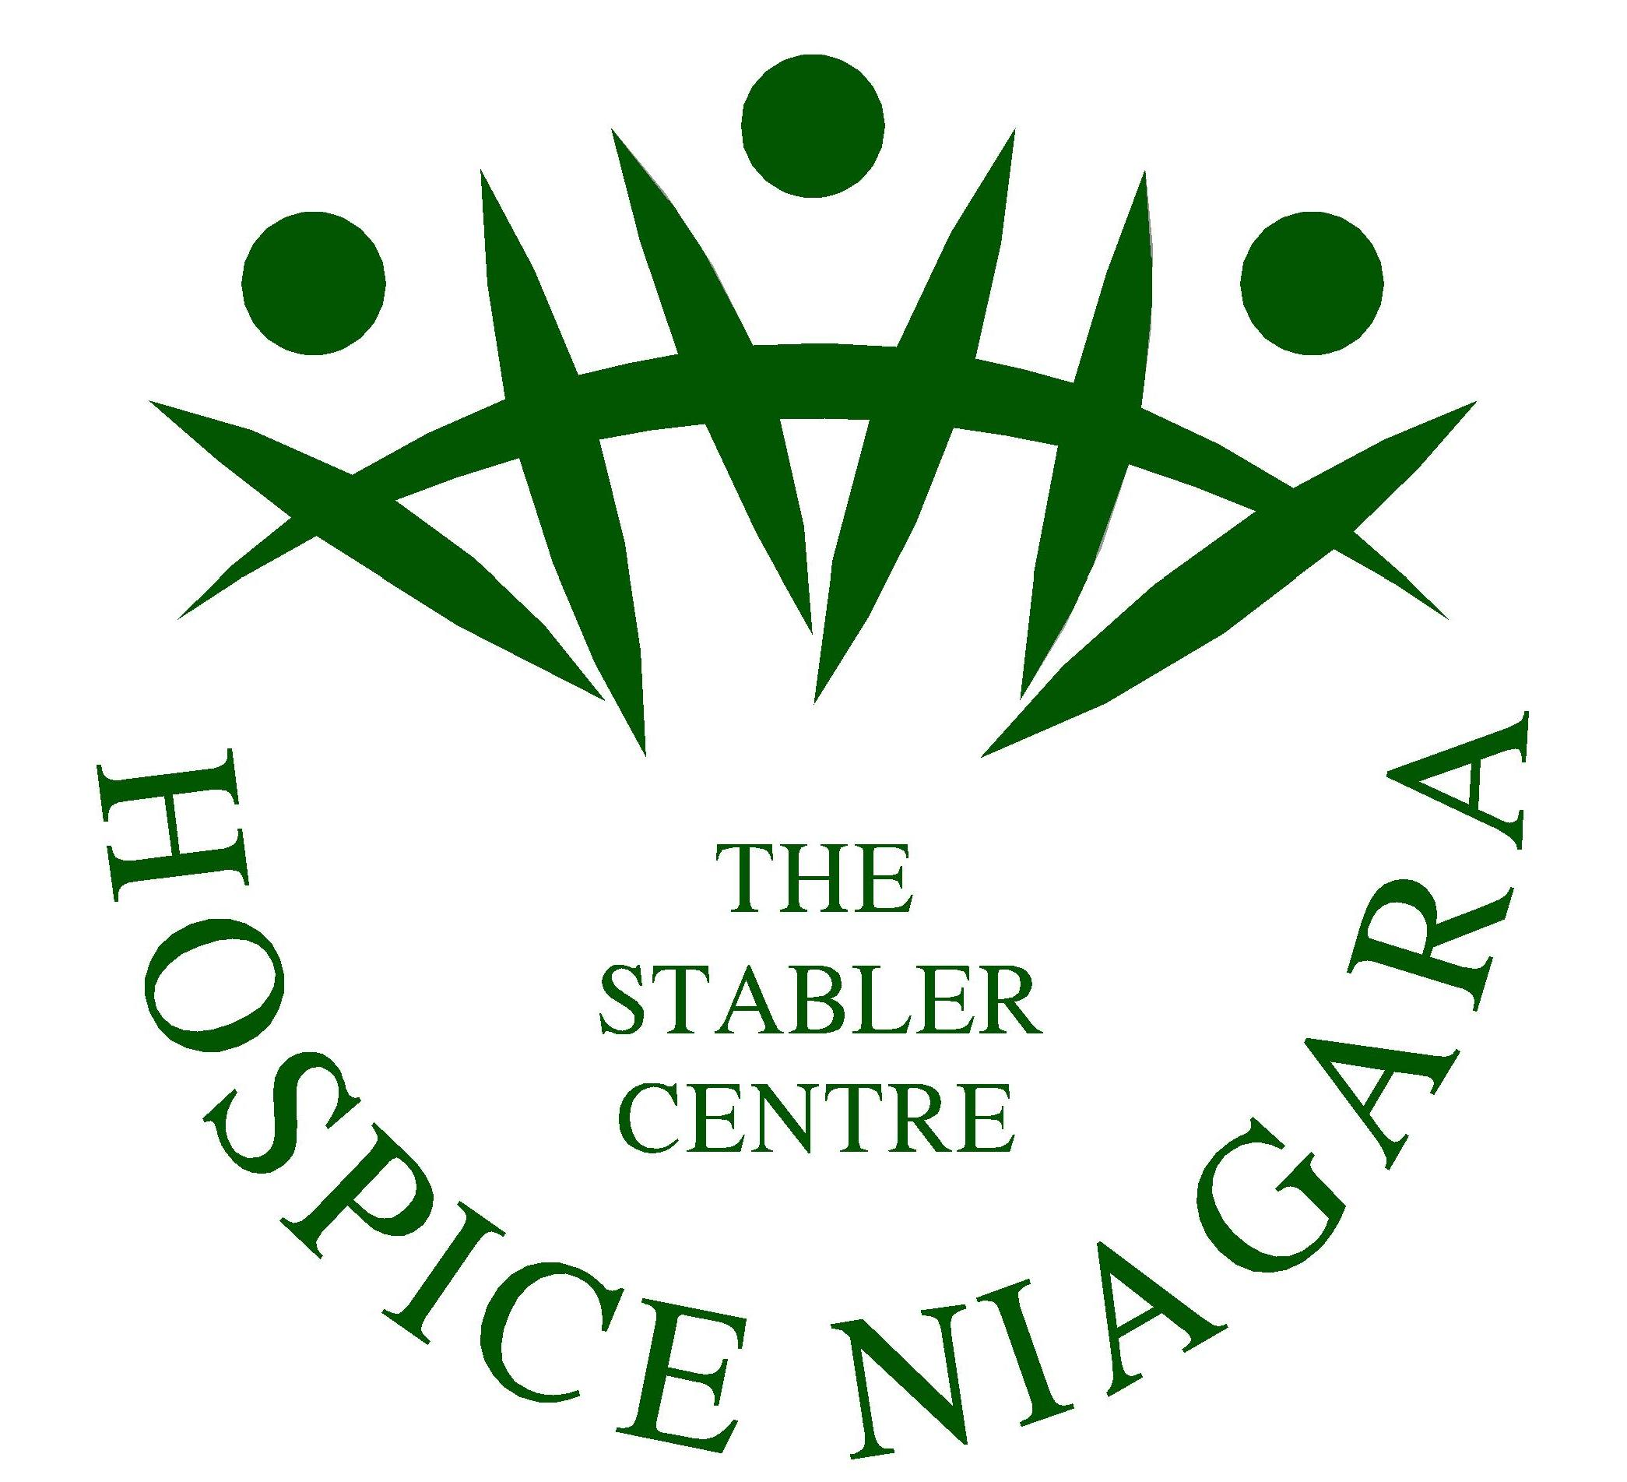
Chef’s Kitchen Orientation for Staff and Volunteers
- Chef’s Kitchen
Sanitary requirements:
- Apply hair net (everyone, even if not preparing food) or a hat may be worn instead
- Men with facial hair must wear a mask/hair net to cover facial hair
- Long hair must be tied back
- On entering kitchen use alcohol based hand wash
- Fingernails must be clean and trimmed
- Gloves are provided for cracked or bleeding hands
- Anyone with upper respiratory infection will not be permitted in The Stabler Centre
- Staff and Residential Volunteers are encouraged to complete the Safe Food Handlers course through Public Health. Kitchen Helper Volunteers are required to take this course.

- Chef’s Fridge
- No items purchased by family members may be stored in the chef’s fridge or freezer.
- Chef must be responsible for all food items in chef’s fridge and freezer.
- All food items must be dated, properly identified, and properly wrapped.
- When offering meals, please offer meals designated for that day on the Menu Calendar created by the Chef. (It is taped on the fridge)
- When cooking meals, please cook meals designated for that day on the Menu Calendar created by the Chef.
- The Chef’s freezer must always be kept locked in order to maintain its regulated temperature of (-18 and -21).
- Lunch meat once opened, must be dated and if not used in its entirety, discarded after 4 days.

- Chef’s Stove
- Never place pots, pans, fry pans or other vessels on the shelf above the burners on the stove.
- Prior to turning on the gas for stove or oven use, turn on the exhaust fan situated on the wall to the right of the stove.
- Never leave stove unattended when in use. If you are called away from the kitchen, turn off the stove.

- Dishwasher
- Follow all instructions on wall above dishwasher for use and for end of day shutdown.
- The dishwasher soap and rinse agent are siphoned through tubing directly plumbed to dishwasher and kept on a shelf to the left of the dishwasher.
- Never add anything to the dishwasher unless you are de-scaling it, as on the de-scaling instructions on the wall above the dishwasher.

- Rinsing Sink
- At the end of the day, inserts from the rinsing sink must be put through dishwasher cycle, and the rinsing sink can be cleaned thoroughly at the same time.

- After food prep cleaning
- All surfaces must be cleaned with bleach solution (100 ppm), then wiped with Oxyvir and left to dry.

